DAT 602

HARPRIT Singh

https://github.com/Harprit-singh/DAT602-milestone-2.git

Milestone 1

Harprit singh

Ground zero

Table of Contents

1MILESTONE ONE

1. Game Description 3

1.1 Base Idea 3

1.2 Logging In 3

1.3 Game Lobby 4

1.4 Gameplay 4

1.4.1 One on One Games 4

1.4.2 Two on Two Games 4

1.4.3 Objective and Scoring 4

1.5 Administrators 5

2. Storyboards 5

Storyboard 1 – Login Screen 5

Storyboard 2 – User Not Found 6

Storyboard 3 – Register a new Account 6

Storyboard 4 – Main Game Lobby 7

Storyboard 5 – One vs One Game Screen 1 7

Storyboard 18 – Administrator Window 8

Storyboard 19 – Administrator Create/Edit User 8

Storyboard 20 – Password Incorrect 8

Storyboard 21 – Account has been Locked 9

2.1 Screen Design Rationale 9

2.1.1 Login/Registration Screen 9

2.1.2 Game Lobby 10

2.1.3 Game Screen 10

2.1.4 Administrator Screens 11

3. Entity Relationship Diagram 11

4. CRUD Table 13

4.1 CRUD Analysis 13

5. SQL ……………………………………………………………………………………………………………………………………………16

6. Mielstone2

Ground Zero

Ground Zero is a multiplayer 2D game. A player drives a laser shooting tank to battle the enemies. The enemies come in a descending way and the time will be provided to score points. The objective is to stay alive and score as many points you can during the time provided. However, the game will be finished when you run out of time.

***Logging IN***

A login page will pop up after clicking the play button. The user had to write his/her username and password and then press sign in, the game will check the database to look that the password is correct. However, if the user details match the database then, game lobby will appear.

What if it does not match?

While entering the details if the password does not match than a message box will pop up, explaining that the user has enter the wrong password. After clicking ‘ok’ then the password box will get empty after then a user can create an account and click on sign up page button to register as a user and then can access gameplay screen.

An admin support will be required to unlock and if the user attempt failed to login more than 3 times.

***Game lobby/ matchmaking screen:***

Once the user has successfully logged in the matchmaking screen will appears. Admin in parenthesis will be written if the user is set as administrator and for normal user it won’t be visible and the word ‘user’ is written in parenthesis.

A box will be shown after logging which will show list of user’s name and number of people playing the game. A maximum of three users can play a game at the same time. To play the current game the user had to click on his own name then a message box will pop up wishing a question that “Do you want to join the game”? and clicking Yes will make him enter in the game.

Logout button will be provided for the users if the user wants to logout. However, if the user is set as administrator and wants to make changes to their account details such as changes in password or delete account so he or she can click on // Your account info// button. After making changes the user will go back to the login screen.

To exit the screen, press the cross in the top right corner.

***Game play :***

After selecting option of playing type the game starts with a tank which moves from to left to right shooting aliens within time provided. The user will start with a tank which will shoots aliens with the time provided. Below I have explained the difference between single and double player.

**Single player**:

Playing as a single player is fun and entertainment. The player can shoot as many as aliens.

**Double player**:

In Double player there will be two tanks which will do the same function as a single player. The game play will also be same.

***Objective and scoring:***

Scoring in this game is quite easy, time will be provided, and the user can score many points, but within time provided. After the users gets out of time the score will be calculated.

***Administrators:***

Administrators plays an important role in any game. Administrator has some special power which allow them to do certain things which allow them to do certain things that normal player cannot. Special powers include killing game that one in progress, create new users, editing existing user’s details or even deleting a user’s account. When creating new users, editing users an administrator will also be able to look or unlock accounts and even great another user admin privileges.

***Story board***

1. LOGIN

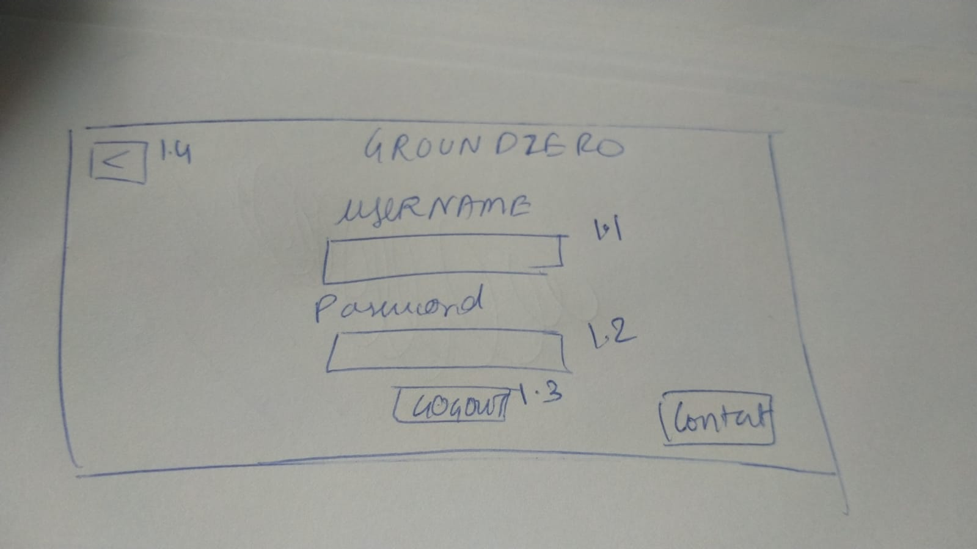

* 1. Text Box will be provided in which the user selected his name and after that it will move to 1.2.
  2. In this text box the user had to write password, the user will get five attempts to write correct password and trying the last time it will locked.
  3. Login button allows the user to enter the game if the account is register.
  4. This button is kind of exit and after clicking this it will take you back to username entry.

1. User not found.

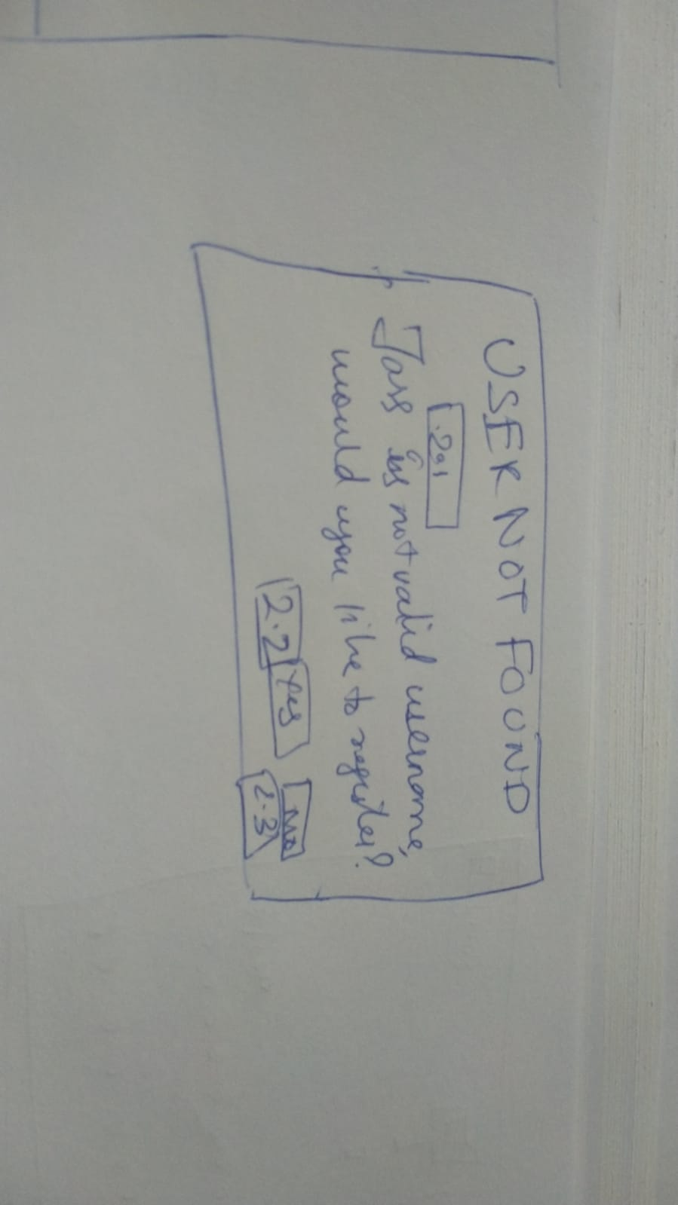

* 1. A dialog will pop up saying that user is not found.

2.2 Clicking yes button will take you to story board 3.

2.3 Selecting no option will take you to story 1.

1. Register a new account:

3.1 The user had to provide his email address.

3.2 To write username.

3.3 Create a password.

3.4 clicking on Register button will allow you to move to storyboard 4

3.5 Button to exit.

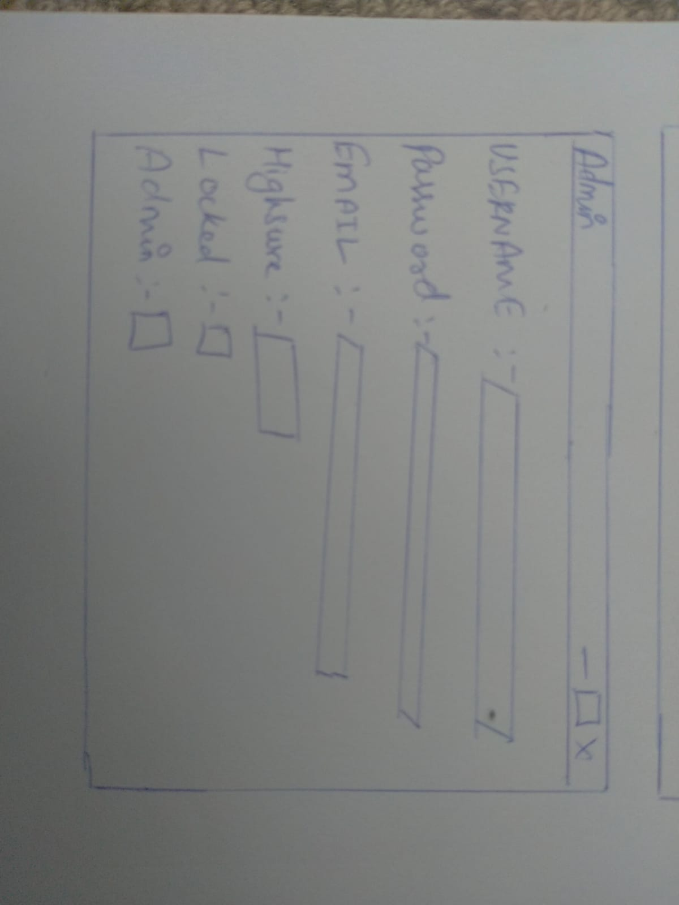

1. Main game lobby:

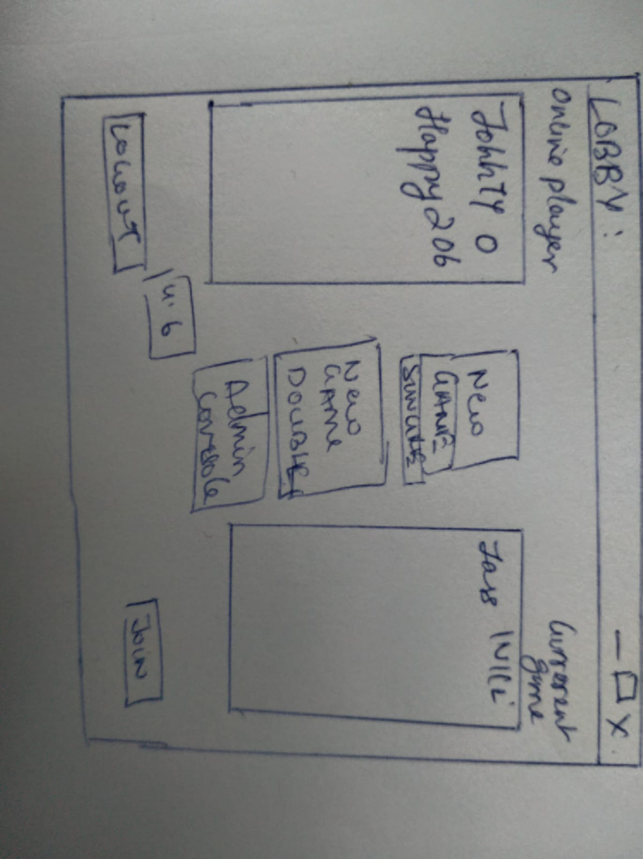

4.1 It will show list of players that are currently online with their highest score.

4.2 This button is to start the game as single player.

4.3 This button is to select the game as double player.

4.4 This button is only visible if the user is set as administrator.

4.5 Logout button will let you exit the game.

4.6 Join button will help you to join the existing game if it is saved.

1. Single player

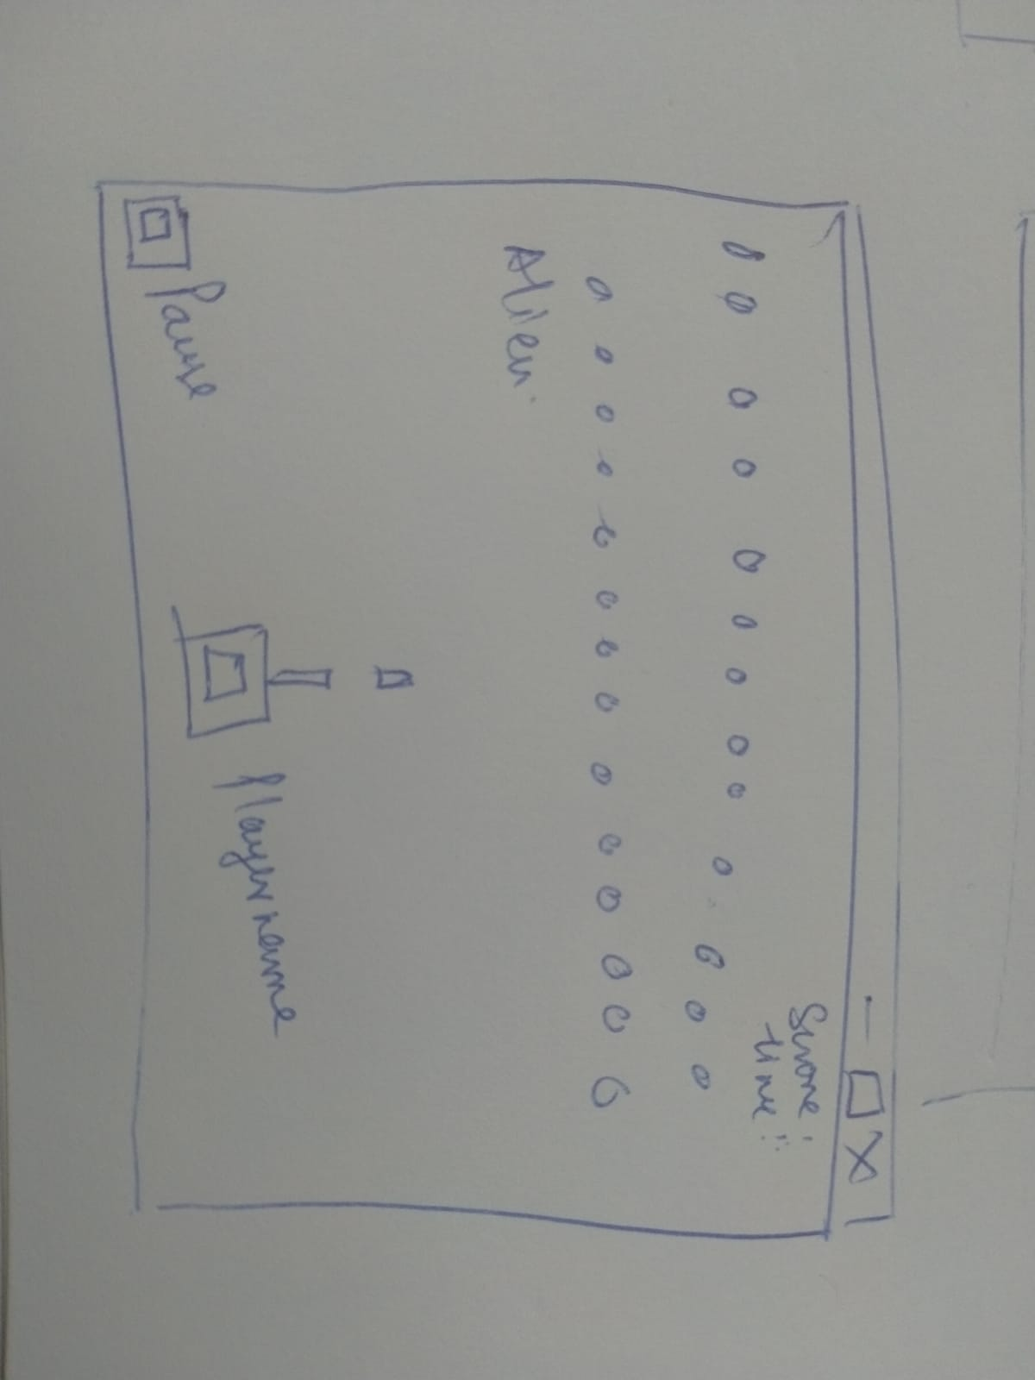

1. Double player
2. Game over: Your score
3. Administrator window:

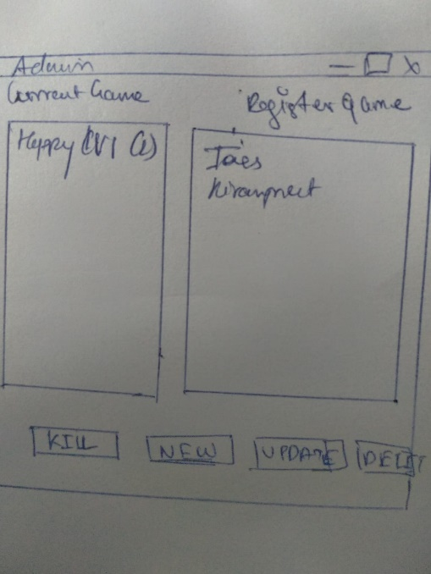

8.1 This box shows list of current games with number of players in that game.

8.2 This box shows list of current registered players.

8.3 Button can be used to kill the selected game.

8.4 This button for admin who can create a new user.

8.5 This button is for admin to update the select user’s details.

8.6 To delete the selected user.

9) Administrator creator:

Text box to enter/alter a username.

Text box to enter a password.

Text box to enter email address.

Select the option to make the user as admin.

To save changes and to proceed ahead then click on create button.

10)Login

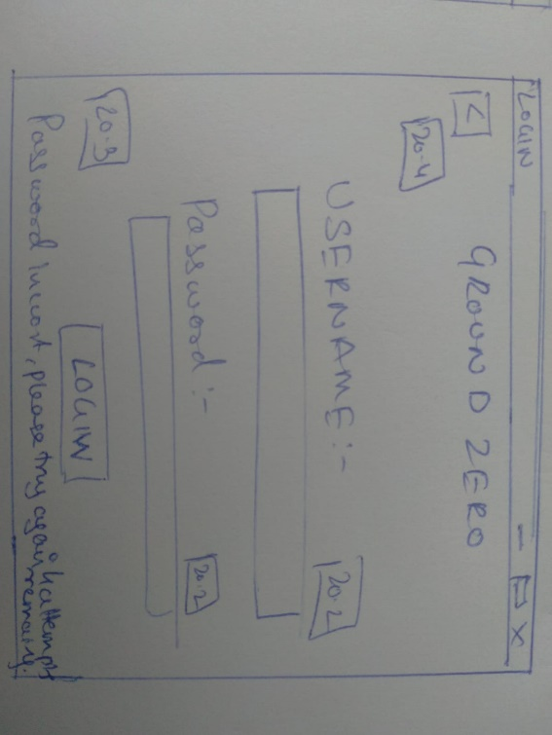

Text box to write username.

Textbox to write password.

If the password does not match then it will show this message “Password is incorrect, 4attempts remaining “. If it does then it will move to next page

11) Account locked

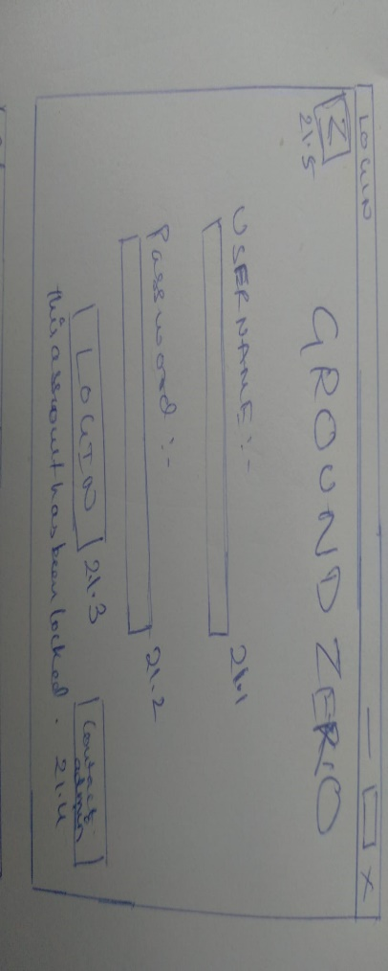

Text box to write username.

Textbox to write password.

After attempting for 5 times the account will get locked and a message will displayed saying that your user account is locked.

Button for user to go back.

Button to contact admin which have administrator detail.

Screen design rationale:

2.1 Login screen is design in a simple way with classic sign in button. It has been designed according to project brief with checking username and password and let know that they are in database.

2.2 Game lobby:

Game screen is simple with brown color background and stones on the field. Lighting shooting laser too kill aliens.

* 1. Admin screen:

The admin screen will do the same function as I previous explain.

1. ***ERD***

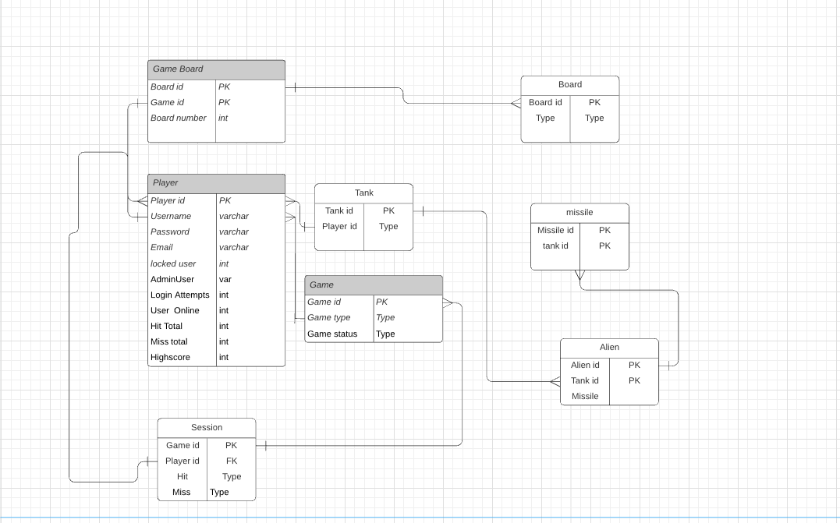

1. Player table contains information of the player, includes the attributes as shown in the diagram. Many players can have many games on many boards.
2. Since several players can enter several games and many games can have several players, a join table is needed between these two tables. The session table stores information about the player's statistics during the game and links players to games in such a way that a single player can run several instances of the game at the same time.
3. In the game the important part join is between player and tank. Tank uses missile to shoot aliens and relationship between all three. 

4)CRUD TABLE:

|  |  |  |  |  |  |  |  |  |  |  |  |  |  |  |  |
| --- | --- | --- | --- | --- | --- | --- | --- | --- | --- | --- | --- | --- | --- | --- | --- |
| Entity/Attribute | **Check Username in Database** | **Register New User** | **Check Password against Username** | **Lock Account** | **Successful Login/Lobby Loads** | **Start New Game** | **Join Existing Game** | **Player Moves** | **Game Ends** | **Player Logs Off** | **Open Admin Console** | **Admin Kill Running Game** | **Admin Delete Player** | **Admin Creates New Player** | **Admin Edits Existing Player Info** |
| **Player** | R | C |  |  | R | R | R |  | RU | RU | R |  | D | RC | RU |
| Player ID |  | C |  |  |  | R | R |  |  | R | R |  | D | C | R |
| Username | R | C | R |  | R |  |  |  |  |  | R |  | D | RC | RU |
| User Password |  | C | R |  |  |  |  |  |  |  |  |  | D | C | RU |
| Email |  | C |  |  |  |  |  |  |  |  |  |  | D | C | RU |
| Locked User | R | C |  | U |  |  |  |  |  |  |  |  | D | C | RU |
| Admin User |  | C |  |  | R |  |  |  |  |  |  |  | D | C | RU |
| Login Attempts | R | C | RU |  | U |  |  |  |  |  |  |  | D | C | RU |
| User Online | R | C |  |  | U |  |  |  |  | U |  |  | D | C | RU |
| Hit Total |  | C |  |  |  |  |  |  | U | U |  | U | D | C | RU |
| Miss Total |  | C |  |  |  |  |  |  | U | U |  | U | D | C | RU |
| High Score |  | C |  |  | R |  |  |  | RU | RU |  | RU | D | C | RU |
| **Game** |  |  |  |  | R | C | R | U | U | U | R | U |  |  |  |
| Game ID |  |  |  |  | R | C | R |  |  |  | R |  |  |  |  |
| Type |  |  |  |  | R | C | R |  |  |  | R |  |  |  |  |
| Game Status |  |  |  |  |  |  |  |  | U | U | R | U |  |  |  |
| **Session** |  |  |  |  | R | C | CR | U | R |  | R | R | D |  |  |
| Player ID |  |  |  |  | R | C | CR |  |  |  | R |  | D |  |  |
| Game ID |  |  |  |  | R | C | CR |  |  |  | R |  | D |  |  |
| Hit |  |  |  |  |  | C | CR | U | R | R |  | R | D |  |  |
| Miss |  |  |  |  |  | C | CR | U | R | R |  | R | D |  |  |
| Score |  |  |  |  |  | C | CR | U | R | R |  | R | D |  |  |
| **Board** |  |  |  |  |  | C | R | RU |  |  |  |  |  |  |  |
| Board ID |  |  |  |  |  | C | R |  |  |  |  |  |  |  |  |
| Board Type |  |  |  |  |  | C | R |  |  |  |  |  |  |  |  |
| **Game Board** |  |  |  |  |  | C | R |  |  |  |  |  |  |  |  |
| Game ID |  |  |  |  |  | C | R |  |  |  |  |  |  |  |  |
| Board ID |  |  |  |  |  | C | R |  |  |  |  |  |  |  |  |
| **Tank** |  |  |  |  |  | C | R | RU |  |  |  |  |  |  |  |
| Tank ID |  |  |  |  |  | C | R | R |  |  |  |  |  |  |  |
| Player ID |  |  |  |  |  | C | R | R |  |  |  |  |  |  |  |
| Alien |  |  |  |  |  | C | R | R |  |  |  |  |  |  |  |
| Alien id |  |  |  |  |  | C | R | R |  |  |  |  |  |  |  |
| Tank id |  |  |  |  |  | C | R | U |  |  |  |  |  |  |  |
| Missile |  |  |  |  |  | C | R |  |  |  |  |  |  |  |  |
| Missile id |  |  |  |  |  | C | R | U |  |  |  |  |  |  |  |
| Tank id |  |  |  |  |  | C | R | U |  |  |  |  |  |  |  |

CRUD ANALYSIS:

The Logical ERD that was developed, which included all the entities and attributes, helped to fill in the left column for the CRUD analysis, and then the storyboards and project specifications were analyzed to decide the events that needed to be analyzed, as well as to insured that the concept and idea were meeting the requirements.

Check Username in Database

A query would look something like this:

***SELECT*** *Username, LockedUser, LoginAttempts, UserOnline* ***FROM*** *tblPlayer*

***WHERE*** *Username = ‘jass’;*

The user would then be asked to register if no records were found; otherwise, the player would be reviewed to see if they were locked, how many login attempts they had left, or whether the username was already signed in.

Register new Users:

According to design it will only enter details which are new.

Check password Against username:

To check password, we use this query, but this method is insecure. If the record is found the player will login in successfully or he/she will be given 5 attempts to login. However, if he could not login so he will be locked and had to contact administrator.

*.* ***SELECT*** *Username, UserPassword* ***FROM*** *tblPlayer*

***WHERE*** *Username = ‘[Username]’* ***AND*** *UserPassword = ‘[Password]’*

*Start new game:*

*Starting new game is easier because in this we just to create new records in the database. Which will include new id, table and two new records.*

*Join existing game:*

*Making the user join his existing game is important role with mixture of creating and retrieving records and make them join together.*

*Game ends:*

*When the game will get ended it will calculate the player hits and the time consume of the game, then their high score will be retrieved along with the score and update it with current game if the user has a new high score.*

Admin updates existing players

When an admin makes a change to an existing player, the database is queried for all of that player's information, which is then used to fill the fields in the window.

If the administrator wants to modify the username, the database will search to see if the new username already exists; if it does, an error will occur; if it does not, the record will be changed.

Admin creates player:

In the admin console new player will be created and the working of console is to check that the username is there or not. If the user already have an account it will show error and if not then id will be created.

5. SQL

(Separate file attached)

**Milestone 2**

The importance of Multi support player and ACID

According to (*The Role of ACID in the Integrity of Your Database Data*, 2017) The full form of ACID *atomicity, consistency, isolation,* and *durability*. Each of these four characteristics contributes to a transaction's capacity to assure data integrity.

Atomicity: Atomicity means that a transaction must exhibit an “all or nothing” behaviour. Either all the instructions within the transaction happen successfully, or none of them happen. Atomicity preserves the “completeness” of the business process.

The status of the data before and after the transaction is referred to as consistency. A transaction ensures that the data state remains consistent. In other words, when a transaction has been completed, all data in the database is "accurate."

Transactions can execute concurrently due to isolation. Any concurrent transactions give the impression that there is no concurrency. In other words, the system appears to be performing just one transaction at a time. No other concurrent transaction has access to the uncommitted database changes made by other transactions.

The impact of an outage or failure on an ongoing transaction is referred to as its durability. A durable transaction has no effect on the state of data if it terminates unexpectedly. In other words, the data is unaffected by any failures.